“EXPLORING EUROPE” – 6th GRADE
(OCT 2014-MAY 2015)
The 6th Grade carried out a project entitled “EXPLORING EUROPE” from October 2014-May 2015.The idea of working in groups was enthusiastically accepted by all pupils.
We started by emphasizing the common values that had to be adopted during the project and soon afterwards pupils formed three groups and created their own posters. The things that they would like to learn about Europe and the European Union were quite a lot. They were given several worksheets and watched videos on the birth and history of the EU, the member countries, capital cities and flags, the founding counties of the EU, the EU flag, anthem and symbols. Finally, they had the chance to learn about the Euro, the EU institutions and play online games and quizes. They collaborated, drew, coloured, filled in, listened, learnt and most important enjoyed themselves. Congratulations to all!!
Dimitra Gamvrelli
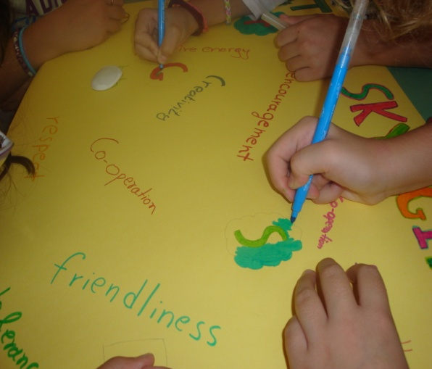
Teacher of English
